Bash Scripting Suite for System Maintenance
Objective: Write a suite of Bash scripts to automate system maintenance tasks such as backup, system updates, and log monitoring.

Day-wise Tasks:
Day 1: Write a script for automated system backups.
Code-
#!/bin/bash
source "$(pwd)/lib.sh"
read -p "Enter folder path to backup: " SRC
[ -z "$SRC" ] && SRC="$(pwd)"
if [ ! -d "$SRC" ]; then
log "ERROR: $SRC is not a valid directory."
exit 1
fi
BACKUP_DIR="$BASE/backups"
mkdir -p "$BACKUP_DIR"
FILE_NAME="backup-$(basename "$SRC")-$(date '+%Y%m%d_%H%M%S').tar.gz"
log "Starting backup of $SRC..."
if tar -czf "$BACKUP_DIR/$FILE_NAME" -C "$(dirname "$SRC")" "$(basename "$SRC")"; then
log "Backup completed successfully: $BACKUP_DIR/$FILE_NAME"
else
log "Backup failed!"
fi
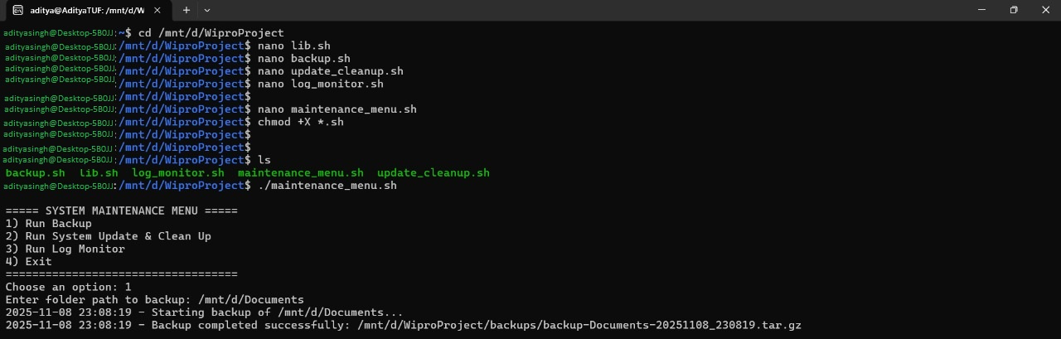

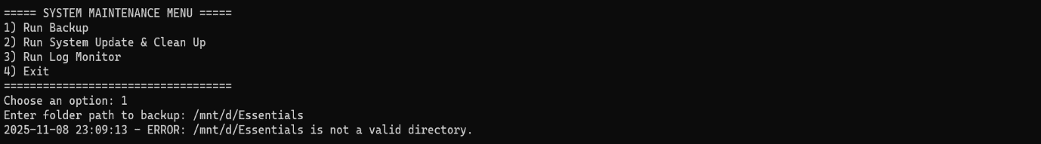

Day 2: Create a script to perform system updates and clean up.
Code-
#!/bin/bash
source "$(pwd)/lib.sh"
log "Running system update..."
if sudo apt update -y && sudo apt upgrade -y; then
log "System updated successfully."
else
log "System update failed!"
fi
log "Cleaning unused packages and cache..."
sudo apt autoremove -y && sudo apt clean
log "Cleanup completed!"
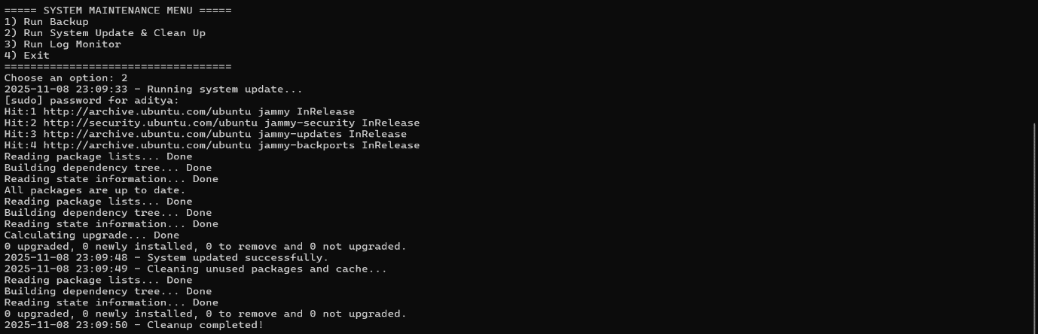

Day 3: Develop a log monitoring script to alert on certain conditions.
Code-
nano#!/bin/bash
# log_monitor.sh - watches a log file for errors
source "$(pwd)/lib.sh"
read -p "Enter log file to monitor (default /var/log/syslog): " FILE
[ -z "$FILE" ] && FILE="/var/log/syslog"
log "Monitoring $FILE for errors..."
# watch for words like ERROR or FAIL
tail -f "$FILE" | grep --line-buffered -Ei "error|fail|critical" | while read line
do
log "ALERT: $line"
done
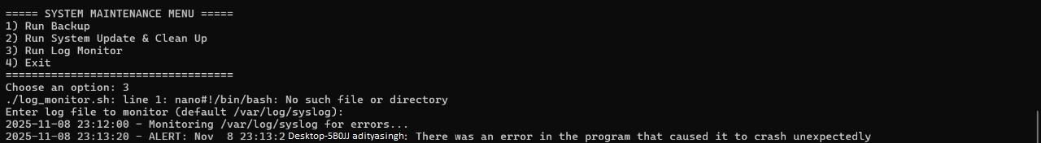

Day 4: Combine scripts into a maintenance suite with a menu to execute them.
Code-
#!/bin/bash
# maintenance_menu.sh - system maintenance suite
while true; do
echo ""
echo "===== SYSTEM MAINTENANCE MENU ====="
echo "1) Run Backup"
echo "2) Run System Update & Clean Up"
echo "3) Run Log Monitor"
echo "4) Exit"
echo "==================================="
read -p "Choose an option: " choice
case $choice in
1) ./backup.sh ;;
2) ./update_cleanup.sh ;;
3) ./log_monitor.sh ;;
4)
echo "Exiting... Goodbye!"
break
;;
*) echo "Invalid choice, try again." ;;
Esac
done
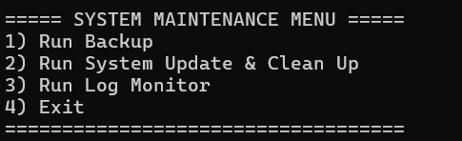

Day 5: Test scripts and add error handling and logging functionalities.
Code-
#!/bin/bash
BASE="$(pwd)"
LOG_DIR="$BASE/logs"
mkdir -p "$LOG_DIR"
LOG_FILE="$LOG_DIR/main.log"
log() {
echo "$(date '+%Y-%m-%d %H:%M:%S') - $1" | tee -a "$LOG_FILE"
}
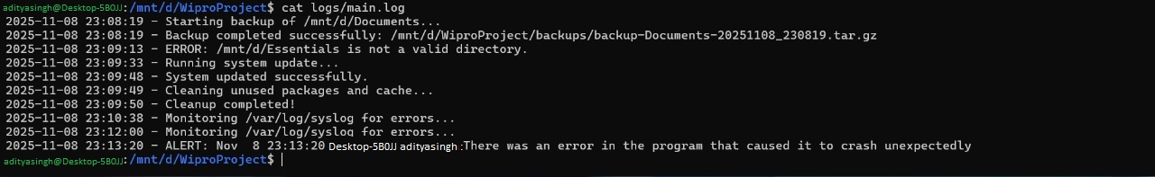

Name – ADITYA KUMAR SINGH
Regd. No.- 2241019456
Batch No. - 02

